Dave Nearing

Professor Hull

EN 103-006

4 October 2010

A Marvel-ous Metaphor:

An Analysis of Dystopian Political Subtexts in Marvel Team Up #5

It has been said that absolute power corrupts absolutely, and what power can be more absolute than total telepathic control over The Thing, Scarlet Witch, Dr. Strange, and Quasar? In the May 1982 issue of *Marvel Team Up*, a renegade technician at the Project Pegasus government research facility steals and becomes enslaved by the Serpent Crown, an ancient artifact imbued with the essence of Set, the serpent demon. At Set’s behest, the technician used the crown as a psychic weapon in order to make all of the project employees into followers of the cult of the Servants of Set. This done, the longtime project leader and newly born again demon worshipper Myron Wilburn set about using Project Pegasus’ resources to summon 777 counterpart crowns from the multiverse, which would allow him to resurrect Set and accelerate the resurgence of the Serpent Men. This setting provides a surprisingly rich and utilitarian backdrop for the exploration of the dangers of shifting too far from a moderate state of governance.

The generally political spectrum ranges from communism and socialism on the left, to moderate government (balance between freedom and law) in the center, and finally to democracy and anarchy on the right. *Marvel Team Up* strives to show that in the interests of stability, the only viable place for a government to rule from is from a firmly moderate position. In the panel shown below (Appendix A), Project Pegasus is portrayed as a sterile, uniform, unremarkable place, with very little room for creativity. Complex machinery dominates the picture, uniform coloring is used, and a horde of unremarkable and indistinguishable technicians and research personnel dominate the floor space, each very small in relationship to the whole laboratory, but taken as a whole entity are quite large. All of these images bear more than a passing resemblance to communist and anti-communist imagery of the period.

When one incorporates the backstory of the entire comic into the interpretation of the image, the following conclusions can be easily drawn: The vast, complex, overly repressive climate of Project Pegasus drove the technician to steal the crown. Driven mad by conformity, he was drawn to the new type of political thought that the crown represents and asserted his individuality through the anarchic concept of total unchecked individuality. All the while he was also seeking the personal power he feels that the sole favor of Set offers him. Through his efforts to “fight the man,” however, the technician essentially snuffed out his newfound individuality by virtue of his promising a measure of Set’s favor in order to entice followers to his cause. The resulting process of homogenization stripped the technician of his newfound individuality, making him once again part of a horde. To quote F.A. Hayek, Austrian economist and political philosopher, the essential nature of what occurred was that, “The demand for the new freedom was thus only another name for the old demand for…equal distribution…” (Hayek 78) this argument lends itself *a fortiori* to the broader logical conclusion that “Fascism and Communism are merely variants of the same totalitarianism which central control of…activity tends to produce.” (Hayek 43) This observation highlights the cyclic way that the further along an extreme a government starts, the harder and more difficult the revolution away from that form will be, and the farther along the opposite side of the spectrum (i.e. far right to far left, v.v.) the result will manifest.

One is left to assume, then, that had the technician not stolen the crown in the first place, but rather acted in accordance with the principles of the Nash Equilibrium, much of the resulting chaos would not have occurred. The Nash Equilibrium is a mathematical derivation of Locke’s theory of the social contract that states that “a strategy profile…is a Nash equilibrium…if no unilateral deviation in strategy by any single player is profitable for that player” (Nash, 48-49), in other words, a person’s needs are best served when they do what is best for themselves and for the group. In this case, one such action would have been leaving the company to seek more rewarding employment elsewhere, rather than risking the very existence of the Earth in order to pursue personal fulfillment.

The fact that the author incorporates a subtext of Lockeian political theory, Nash’s mathematics, and sentiments about the nature of politics clearly shared by F.A. Hayek into his visual argument in order to prove his point about the political spectrum contributes heavily to establishing the ethos of the piece. Furthermore, since the comic was written in the years leading up to the Cold War with Hayek’s theme that tyranny begets tyranny, its ethical legitimacy should not be brought into question.

As far as the panel’s pathos is involved, however, the author’s overt appeals to sentiment cannot be ignored. Using the fear of losing one’s identity to a snake demon through a transformative process, while useful as an imagistic device, is not an entirely accurate metaphor for an individual changing between different personal political philosophies. Nor does the idea that a single person could completely destroy, rebuild, and reinstate a government in a relatively short time through their actions seem to have any correlation to reality, and so its introduction is merely an attempt to subvert the reader’s emotions and make them more intensely apprehensive of the clear and present danger that they are discussing.

As far as the panel’s logos is concerned, the use of hard lines, uniform coloring, the subjective neutrality of the features of the characters, and the portrayal of the heroes, the “true individuals,” in color and with detail proves to be particularly effective at creating a heavy dystopian feel in tune with the author’s other arguments against communism. The way that this atmosphere is punctuated with metaphorical flashes of light in the darkness in the form of superheroes, obvious individuals with whom the reader can at once identify with and sympathize with. All that when coupled with the assimilative properties of the crown creates an intentional visual conflict between good and evil, and between individualism and collectivism on a deeper level. The use of the snake image as the antagonist also appeals to the reader’s ostensible acquaintance with the story of the Book of Genesis, wherein the serpent tempts Eve into eating from the Tree of Knowledge. This is reflected almost identically through the snake tempting the technician with promises of power.

The use of this particular issue of *Marvel Team Up* as a vehicle for the expression of anti-communist and anti-command sentiments is at once brilliant and disturbing. Is it an acceptable practice to use a primarily entertainment-oriented medium in order to convey a pointed political opinion? Is the theme even intentionally present? Why would the author use a comic, as opposed to some other kind of medium to relay this message to his audience? Unfortunately, this is a comic that presents one with considerably more questions than answers. Quite the Marvel-ous topic for debate, isn’t it?

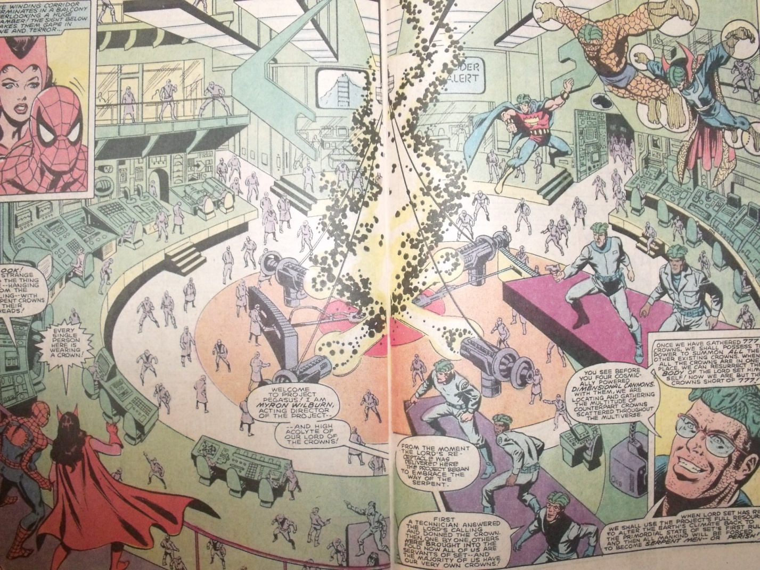Appendix A

(Gruenwald 24-25)

Works Cited

Hayek, F.A. *The Road to Serfdom: Text and Documents— The Definitive Edition.* Chicago: University of Chicago Press, 2007. Print.

Mark Gruenwald. “Serpent Rising.” Marvel Team Up Annual #5 (1982), Marvel Comics Group

Nash, John "Equilibrium Points in n-Person Games" *Proceedings of the National Academy of Sciences* 36(1): 48-49